

AgentEdge:   
Multi-Site Edge

Intelligence System

Pure Edge,   
Agentic Protocols,   
& Local Intelligence

Technical Documentation   
for AI Futures Lab

Pedro Costa  
Head of GenAI   
Capgemini Engineering Middle East  
February 2026

# Table of Contents

**1. The Vision: Edge Agentic AI**

1.1 Agents Are the New APIs

1.2 The A2A Protocol: Interoperability at Scale

1.3 AI at the Edge: Beyond the Cloud

**2. System Architecture**

2.1 Architecture Overview

2.2 Data Flow

2.3 Anomaly Detection Sequence

**3. Hardware & Sensor Module**

3.1 ENS160+AHT21 Sensor Module

3.2 Arduino Integration

3.3 Nvidia Jetson Orin Nano

**4. Protocol Stack**

4.1 MCP: Agent-to-System Integration

4.2 A2A: Agent-to-Agent Collaboration

4.3 Message Types & Schemas

**5. Agent Design**

5.1 Jetson Agent (Site A)

5.2 Mac Agent (Control Center)

5.3 LFM 2.5 Integration

**6. Small Language Models & On-Device Intelligence**

6.1 The Case for Edge Intelligence

6.2 Liquid AI: Leading the SLM Revolution

6.3 Liquid Foundation Models (LFM)

6.4 Capgemini and Liquid AI Partnership

6.5 Why LFM for Agent Edge

**7. Dashboard**

**8. Anomaly Detection & Thresholds**

**9. Deployment**

**10. Security Considerations for Agentic AI at the Edge**

**11. Demo Scenario**

**12. Future Directions**

**13. References & Further Reading**

# 1. The Vision: Edge Agentic AI

We are witnessing a fundamental shift in how distributed systems are designed and operated. The era of passive microservices responding to predetermined API calls is giving way to a new paradigm: autonomous, intelligent agents that perceive their environment, reason about it, and collaborate with peers to make decisions, all without cloud dependency.

Agent Edge is a demonstration of this vision. It brings together three converging trends that are reshaping enterprise and industrial AI:

* **Agents as the new APIs:** Agent-Oriented Architectures replacing traditional SOA and microservices
* **Interoperability protocols:** Google’s A2A protocol enabling cross-vendor, cross-device agent collaboration
* **Edge-native intelligence:** Small, powerful language models (LiquidAI LFM 2.5) running inference locally on edge hardware

This system is not a prototype of the future. It is a working demonstration of what is possible today, using off-the-shelf hardware and open protocols, and of course Agentic software developement.

## 1.1 Agents Are the New APIs

Traditional Service-Oriented Architectures defined rigid contracts between services: fixed endpoints, predetermined request/response schemas, brittle integrations that break when any component changes. Agent-Oriented Architectures introduce intelligent, autonomous agents capable of proactively perceiving, adapting, and dynamically interacting with their environment.

In this new paradigm, agents serve as intelligent intermediaries that:

* Act as secure gatekeepers between disparate systems
* Breathe new life into legacy infrastructure without costly replacements
* Enable seamless communication between diverse components through natural language and structured protocols
* Maintain system integrity while fostering innovation

The implications for IoT and Industry 4.0 are profound. We are moving from the Internet of Things, passive sensor networks that merely transmit data, to the Internet of Agents: dynamic systems where entities actively communicate, negotiate, and coordinate. Industrial devices adapt autonomously to operational conditions. Autonomous vehicle fleets negotiate routes in real time. Power grids self-balance supply and demand. Smart cities become truly intelligent.

Agent Edge demonstrates this concretely: an environmental sensor does not just report numbers. An agent reasons about those numbers, detects anomalies, and collaborates with a peer agent to reach a decision, all at the edge, in real time.

**My full article:** https://www.linkedin.com/pulse/agents-new-apis-pedro-falc%C3%A3o-costa-1ydpf/

## 1.2 The A2A Protocol: Interoperability at Scale

Google’s Agent-to-Agent (A2A) protocol is a major step toward the distributed, modular, and collaborative AI architectures that the industry needs. For the first time, AI agents from different vendors, clouds, and devices can communicate using a shared language.

A2A solves the fundamental isolation problem: agents trapped in proprietary runtimes can finally work together across organizational boundaries. The protocol provides:

* Standardized message types for discovery, observation, analysis, and decision-making
* Built-in security safeguards for collaborative agent networks
* Scalability from single-agent to multi-agent ecosystems
* Edge AI integration for IoT devices and isolated systems

Consider the practical implications: an AI-enabled coffee machine detects performance issues and autonomously contacts maintenance agents, triggering scheduling and parts ordering without human intervention. Solar farm agents monitoring panel output, battery storage, and weather forecasting collaborate in real time to optimize energy management.

Agent Edge implements A2A as its core inter-agent communication layer, demonstrating that this protocol works today on real hardware at the edge.

**My full article:** https://www.linkedin.com/pulse/a2a-protocol-google-here-changes-everything-pedro-falc%C3%A3o-costa-fggff/

## 1.3 AI at the Edge: Beyond the Cloud

The release of compact, high-quality language models has fundamentally changed what is possible at the edge. Models like LFM2.5-1.2B can run entirely on local hardware, a Jetson Orin Nano, a Mac, with no cloud dependency, no data leaving the premises, and no per-token API costs.

This opens transformative possibilities:

* **Extreme environments:** How can AI function in minimal-infrastructure environments?
* **Privacy and security:** Models operating entirely offline with no cloud data transmission
* **Cost reduction:** Eliminating per-query cloud costs for continuous monitoring
* **Latency elimination:** AI reasoning at the point of data generation, not in a distant data center

Innovation isn’t just about technology. It’s about reimagining what’s possible. Agent Edge extends AI capability to scenarios where traditional cloud infrastructure is impractical: factory floors, remote facilities, mobile platforms, and anywhere that demands local intelligence.

**My original post:** https://www.linkedin.com/posts/pedrofalcaocosta_ai-innovation-edgecomputing-activity-7250913453186441216-vAiO

# 2. System Architecture

Agent Edge is a distributed system with two autonomous agents coordinating via A2A protocol. The Jetson Orin Nano (Site A) reads environmental sensors through an Arduino via MCP protocol and performs anomaly detection. The Mac (Control Center) provides historical analysis and hosts the real-time dashboard. Both agents run LFM2.5-1.2B-Thinking locally for reasoning.

## 2.1 Architecture Overview

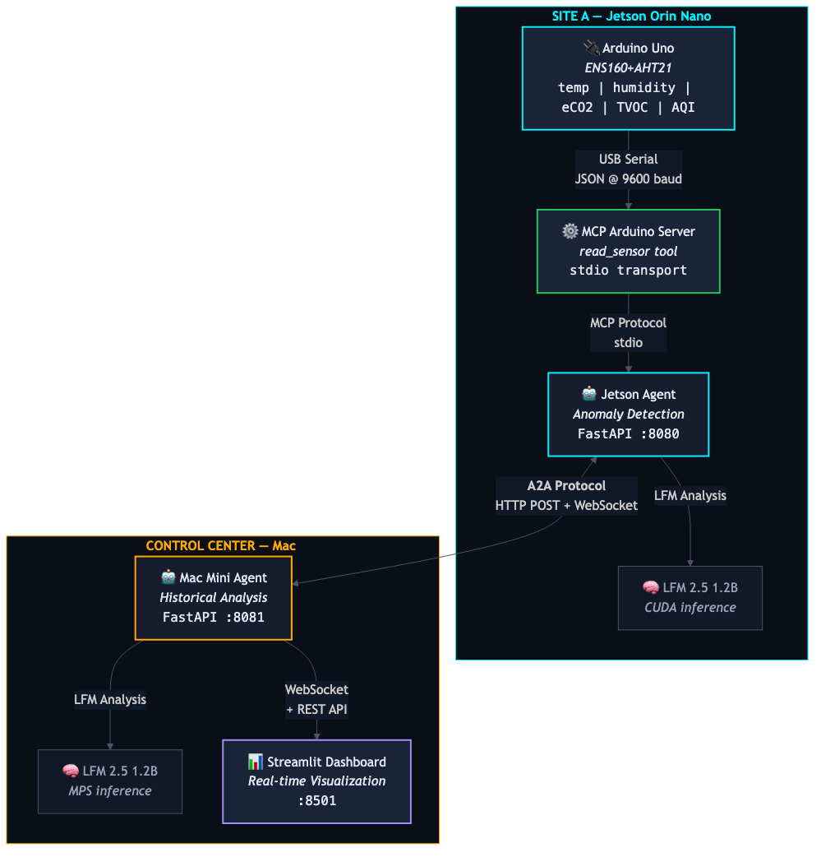

*Figure 1: Agent Edge System Architecture*

The system uses two complementary protocols:

* **MCP (Model Context Protocol):** Agent-to-System integration. The Jetson agent communicates with the Arduino sensor hardware through an MCP server that exposes a read_sensor tool via stdio transport.
* **A2A (Agent-to-Agent):** Agent-to-Agent collaboration. The Jetson and Mac agents exchange structured messages over HTTP POST endpoints, with real-time streaming via WebSocket.

## 2.2 Data Flow

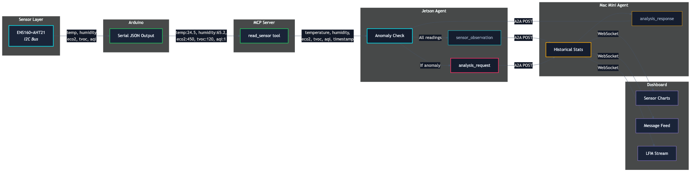

*Figure 2: Sensor Data Flow Through All Layers*

Sensor data flows as a consistent JSON schema through every layer of the system. The ENS160+AHT21 module produces five fields, temperature, humidity, eCO2, TVOC, and AQI, which are preserved from the Arduino serial output through the MCP server, A2A messages, and into the dashboard visualization.

## 2.3 Anomaly Detection Sequence

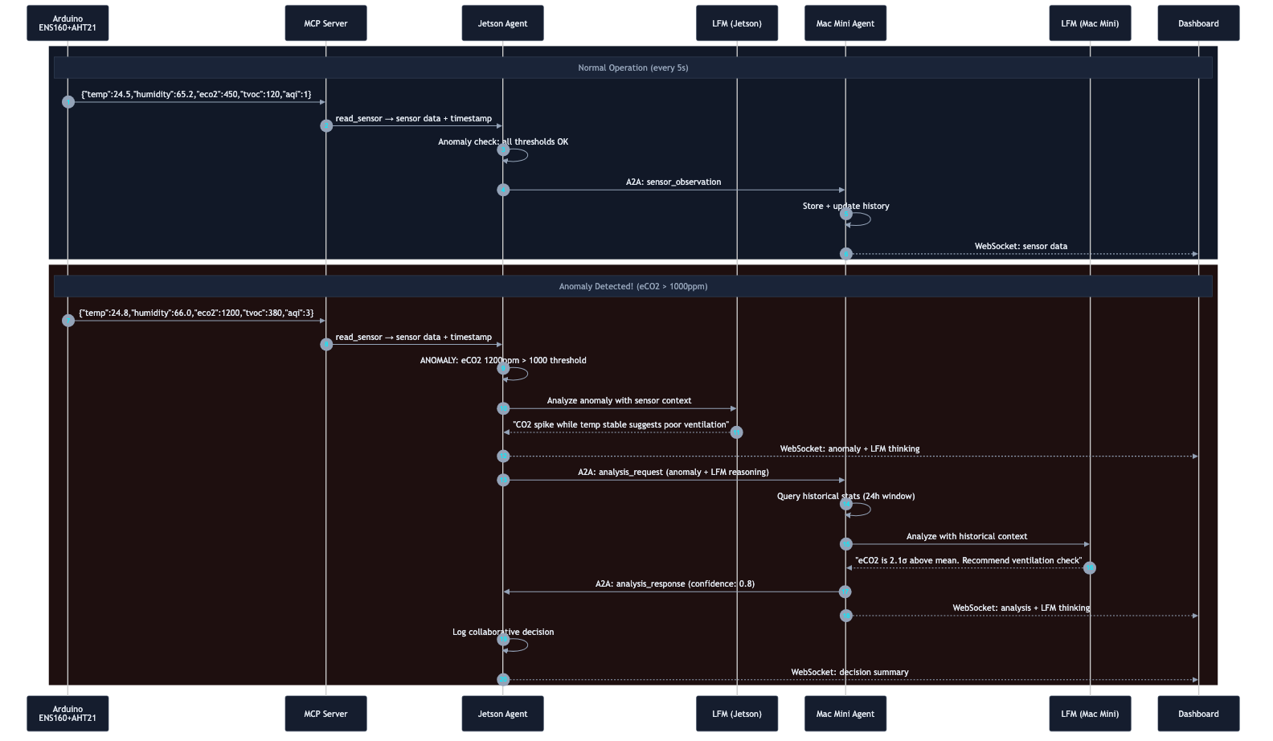

*Figure 3: Anomaly Detection and Collaborative Analysis Sequence*

The sequence diagram above illustrates both normal operation (top) and the full anomaly collaboration flow (bottom). When an anomaly is detected, such as eCO2 exceeding 1000ppm, the Jetson agent runs local LFM analysis, then requests historical context from the Mac agent. Both agents’ LFM reasoning is streamed to the dashboard in real time.

# 3. Hardware & Sensor Module

## 3.1 ENS160+AHT21 Sensor Module

The system uses an ENS160+AHT21 combo module connected to an Arduino via I2C (SDA/SCL). This module provides five environmental parameters:

|  |  |  |  |
| --- | --- | --- | --- |
| Parameter | Sensor | Unit | Range |
| Temperature | AHT21 | °C | -40 to +85 |
| Humidity | AHT21 | % RH | 0 to 100 |
| eCO2 | ENS160 | ppm | 400 to 65000 |
| TVOC | ENS160 | ppb | 0 to 65000 |
| AQI | ENS160 | 1–5 scale | 1 (Good) to 5 (Unhealthy) |

The ENS160 requires approximately 1 minute of warm-up time after power-on, and approximately 1 hour for full calibration. During warm-up, readings may be unreliable.

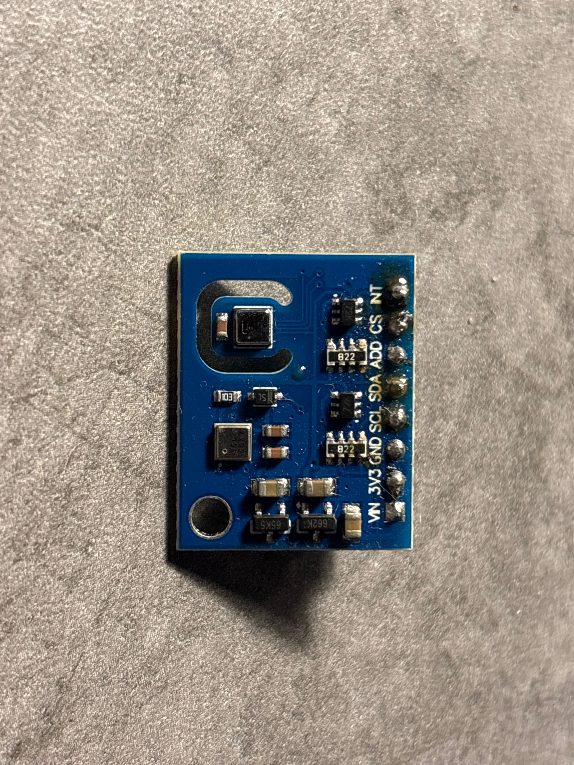

## 3.2 Arduino Integration

The Arduino reads both sensors via I2C and outputs JSON over serial at 9600 baud every 2 seconds:

{"temp":24.5,"humidity":65.2,"eco2":450,"tvoc":120,"aqi":1}

Required Arduino libraries:

* ScioSense_ENS160 , eCO2, TVOC, AQI readings via I2C
* Adafruit_AHTX0 , Temperature and humidity readings via I2C
* Wire.h , I2C communication

The AHT21 temperature and humidity readings are fed to the ENS160 for environmental compensation, improving the accuracy of the air quality measurements.

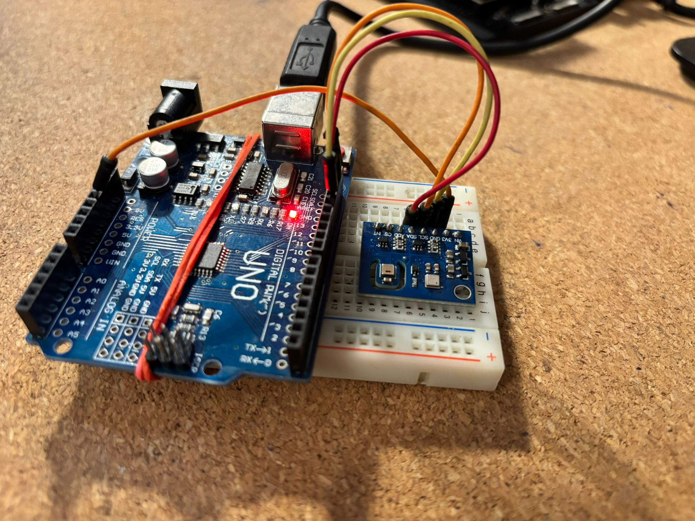

## 3.3 NVIDIA Jetson Orin Nano Super Developer Kit

The Jetson Orin Nano Super Developer Kit from NVIDIA is a compact edge AI computer designed for prototyping robotics, vision, and generative AI applications on-device. It combines an Arm CPU with an Ampere GPU and LPDDR5 memory to deliver up to 67 INT8 TOPS in a small, low power platform, making it suitable for running modern AI workloads locally, including small language models, without relying on cloud connectivity.

* **AI performance:** Up to 67 INT8 TOPS (via the “Super” performance update).
* **GPU:** Ampere architecture with 1024 CUDA cores and 32 Tensor Cores.
* **CPU:** 6-core Arm Cortex-A78AE (64-bit).
* b 8GB 128-bit LPDDR5.
* **Memory bandwidth:** 102 GB/s.
* **Storage:** microSD card slot plus support for external NVMe storage.
* **Power modes:** Configurable, roughly 7W to 25W.
* **Price point:** USD $249 (often referenced as roughly $250) via authorized channels.
* **Allows to run SLMs locally:** Positioned to run a wide range of generative AI models at the edge (including LLMs and vision-language models), typically using optimized runtimes and quantized weights to fit within the 8GB memory envelope.
* **Connectivity:** Onboard Gigabit Ethernet, Wi Fi and Bluetooth support (via the included wireless module), plus multiple USB ports for peripherals and cameras.
* **GPIO and hardware I O:** Standard 40 pin GPIO header (Raspberry Pi style) for interfacing with sensors, actuators, I2C, SPI, UART, and PWM devices.
* 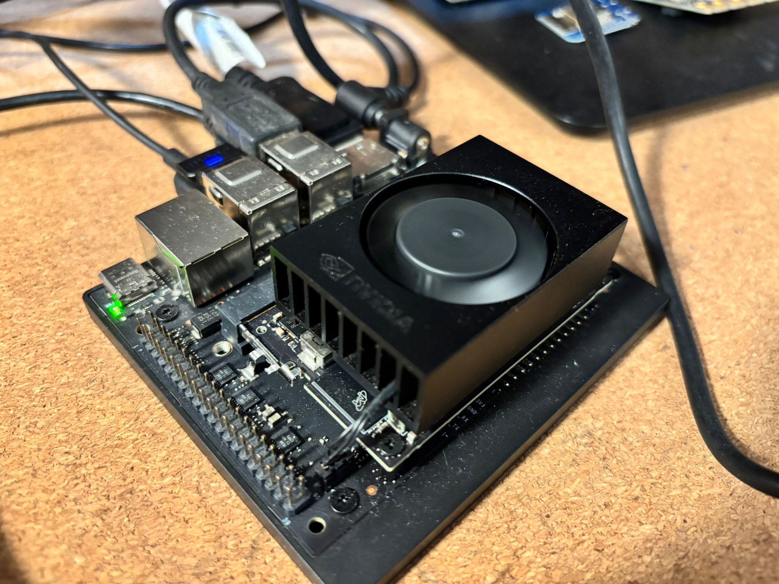

# 4. Protocol Stack

## 4.1 MCP: Agent-to-System Integration

The Model Context Protocol (MCP) provides a standardized way for AI agents to interact with external tools and data sources. In Agent Edge, the MCP Arduino Server exposes the sensor hardware as a tool that the Jetson agent can invoke.

* **MCP Tool:** read_sensor , returns current sensor readings with timestamp
* **Transport:** stdio (subprocess communication)
* **Return format:** JSON with schema: temperature, humidity, eco2, tvoc, aqi, timestamp

## 4.2 A2A: Agent-to-Agent Collaboration

The A2A protocol enables peer-to-peer agent communication. Each agent exposes:

* /a2a/message , HTTP POST endpoint for receiving structured messages
* /stream , WebSocket endpoint for real-time event streaming
* /health , Agent Card and status endpoint

## 4.3 Message Types & Schemas

|  |  |  |
| --- | --- | --- |
| Message Type | Direction | Purpose |
| agent_card | Broadcast | Agent discovery and capability advertisement |
| sensor_observation | Jetson → Mac | Sensor reading with all 5 fields + location |
| analysis_request | Jetson → Mac | Anomaly detected, requesting historical analysis |
| analysis_response | Mac → Jetson | Historical context and LFM reasoning |
| decision | Both agents | Collaborative decision logged by both |
| heartbeat | Bidirectional | Periodic health check (every 10s) |

Sensor observation payload schema:

{  
 "type": "sensor_observation",  
 "from": "jetson-site-a",  
 "to": "macmini-control",  
 "message_id": "uuid",  
 "timestamp": "ISO8601",  
 "payload": {  
 "sensor": "ENS160+AHT21",  
 "temperature": 24.5,  
 "humidity": 65.2,  
 "eco2": 450, // ppm  
 "tvoc": 120, // ppb  
 "aqi": 1, // 1-5 scale  
 "location": "Site A - Server Room"  
 }  
}

# 5. Agent Design

## 5.1 Jetson Agent (Site A)

The Jetson Orin Nano runs the Site A monitoring agent. It is responsible for sensor reading, anomaly detection, and initiating collaborative analysis.

Responsibilities:

* **Startup:** Initialize MCP client to Arduino sensor server
* **Sensor loop:** Read sensor every 5 seconds via MCP, send observations to Mac
* **Anomaly detection:** Check 4 thresholds on every reading; trigger LFM analysis if any exceeded
* **A2A handling:** Process analysis responses, log collaborative decisions

Configuration:

AGENT_ID = "jetson-site-a"  
AGENT_PORT = 8080  
SENSOR_POLL_INTERVAL = 5 # seconds  
TEMP_DELTA_THRESHOLD = 5.0 # degrees C  
ECO2_THRESHOLD = 1000 # ppm  
TVOC_THRESHOLD = 500 # ppb  
AQI_THRESHOLD = 4 # 1-5 scale

## 5.2 Mac Agent (Control Center)

The Mac runs the Control Center agent. It maintains historical sensor data, performs statistical analysis, and provides context for anomaly evaluation.

Responsibilities:

* Maintain rolling window of sensor readings (all 5 fields, last 24 hours)
* Calculate per-field statistics: mean, standard deviation, min, max
* Provide multi-parameter context (e.g., “CO2 spiking while temperature stable”)
* Run LFM analysis with historical context when analysis requests arrive
* Host dashboard data APIs and WebSocket streams

## 5.3 LFM 2.5 Integration

Both agents run Liquid AI’s LFM2.5-1.2B model locally. The Jetson uses CUDA acceleration; the Mac uses Apple’s MPS (Metal Performance Shaders). The LFM client supports:

* Token-by-token streaming for real-time dashboard visualization
* Structured prompts for anomaly detection, historical analysis, and collaborative reasoning
* GPU-accelerated inference with automatic device detection (CUDA/MPS/CPU)

# 6. Small Language Models & On-Device Intelligence

The AI industry has spent the last several years in a relentless pursuit of scale: larger models, bigger clusters, more parameters. But a parallel revolution has been quietly gaining momentum, one that may ultimately prove more consequential for how AI is actually deployed in the real world. Small Language Models (SLMs) are redefining what is possible at the edge, on device, and in environments where cloud connectivity is a luxury, not a given.

Agent Edge is built on a fundamental conviction: the future of AI is not exclusively in the cloud. It is at the edge. It is on the device. It is wherever decisions need to be made, fast, private, and without dependency on a data center thousands of kilometers away.

## 6.1 The Case for Edge Intelligence

Cloud-based AI has an undeniable role, but it comes with constraints that are unacceptable in many real-world scenarios:

* **Latency:** Every API call is a round trip. For real-time monitoring, autonomous vehicles, and industrial control, even 100ms of latency is too much.
* **Privacy:** Sensitive sensor data, patient records, factory telemetry, organizations increasingly cannot or will not send this data to external servers.
* **Connectivity:** Factory floors, offshore platforms, remote facilities, vehicles in tunnels, many critical environments have intermittent or no connectivity.
* **Cost:** Continuous inference through cloud APIs creates compounding costs that make always-on monitoring economically impractical.
* **Sustainability:** The energy footprint of routing billions of inference requests through hyperscale data centers is unsustainable at global scale.

On-device intelligence eliminates these constraints entirely. When a 1.2B parameter model runs locally on a Jetson Orin Nano or a Mac, inference is instantaneous, data never leaves the premises, and the system operates independently of network conditions. This is not a compromise, for edge use cases, it is superior architecture.

## 6.2 Liquid AI: Leading the SLM Revolution

Liquid AI, a spin-off from MIT’s Computer Science and Artificial Intelligence Laboratory (CSAIL), has taken a fundamentally different approach to foundation models. Rather than competing in the parameter arms race, Liquid AI has focused on building the most efficient models at every scale, models that are designed from the ground up for on-device deployment.

The core innovation is Liquid Neural Networks (LNNs): a new class of neural architecture that is more robust, computationally smaller, and less memory-intensive than traditional transformer models. Where conventional LLMs require massive GPU clusters, Liquid’s models achieve competitive quality while running on CPUs, NPUs, and embedded processors with minimal memory footprint.

Liquid AI’s decision to release open-weight models was a pivotal strategic move. By making LFM weights available on Hugging Face, they have enabled an entire ecosystem of developers, researchers, and enterprises to build on their technology. This openness, combined with native support for llama.cpp, MLX, vLLM, and ONNX across Apple, AMD, Qualcomm, and NVIDIA hardware, positions Liquid AI to lead the SLM space in a way that closed-model providers cannot.

I firmly believe that Liquid AI will be a defining force in the Small Language Model space. Their combination of MIT-grade research, open weights, hardware-optimized architectures, and a clear focus on the edge makes them uniquely positioned to enable the next generation of on-device intelligence, from wearables and mobile phones to autonomous vehicles and industrial IoT.

## 6.3 Liquid Foundation Models (LFM)

The LFM2.5 family represents the latest generation of Liquid Foundation Models, with extended pretraining from 10 trillion to 28 trillion tokens and significantly scaled post-training via reinforcement learning.

The LFM2.5 model family includes:

|  |  |  |
| --- | --- | --- |
| Model | Parameters | Capability |
| LFM2.5-1.2B-Base | 1.17B | Pretrained checkpoint for fine-tuning |
| LFM2.5-1.2B-Instruct | 1.17B | General-purpose instruction following |
| LFM2.5-1.2B-Thinking | 1.17B | On-device reasoning under 1GB |
| LFM2.5-1.2B-JP | 1.17B | Japanese language optimization |
| LFM2.5-VL-1.6B | 1.6B | Vision-language understanding |
| LFM2.5-Audio-1.5B | 1.5B | End-to-end audio and text generation |
| LFM2-8B-A1B | 8B (1B active) | Mixture-of-experts efficiency |

Key technical characteristics:

* **Architecture:** 16-layer hybrid architecture: 10 double-gated LIV convolution blocks + 6 GQA attention blocks
* **Context length:** 32,768 tokens, enabling complex RAG tasks and long-form data extraction
* **Inference speed:** 2,975 tok/s prefill, 116 tok/s decode on AMD Ryzen AI 9; 335 tok/s prefill on Snapdragon Gen4 mobile CPU
* **Languages:** English, Arabic, Chinese, French, German, Japanese, Korean, Spanish
* **Deployment targets:** Vehicles, mobile devices, laptops, IoT devices, embedded systems, edge servers

The LFM2.5-1.2B-Thinking variant is particularly relevant for Agent Edge: it enables on-device reasoning in under 1GB of memory, making it feasible to run chain-of-thought analysis on edge hardware for anomaly detection and collaborative decision-making.

## 6.4 Capgemini and Liquid AI Partnership

Capgemini and Liquid AI have established a strategic collaboration to build next-generation AI solutions for enterprises. Capgemini’s Corporate VC fund (ISAI Cap Venture) participated in Liquid AI’s $37.6 million seed round in 2023, and the partnership has since deepened into a joint effort to bring on-device AI to production at enterprise scale.

The collaboration focuses on deploying smaller, more sustainable generative AI models compatible with offline and edge devices, with applications spanning manufacturing, healthcare, finance, and industrial IoT. As Andrew Vickers, CTO Generative AI at Capgemini Engineering, stated:

*“We’re thrilled to be continuing our relationship with Liquid AI, a relationship born from our Strategic University Research Partnership Program with MIT. Liquid AI brings amazing technology to the market, in tune with the needed trends of simplicity, efficiency and sustainability.”*

Ramin Hasani, Co-Founder and CEO of Liquid AI, added:

*“Our cooperation with Capgemini allows us to combine our cutting-edge AI technology with Capgemini’s global reach and expertise, ultimately benefiting organizations across various industries to develop and deploy private, reliable and best-in-class domain-specific and generalist AI systems.”*

Agent Edge is a direct expression of this partnership’s vision: Liquid AI’s models running on edge hardware, orchestrated by Capgemini’s expertise in distributed systems and agent architectures, demonstrated through Capgemini’s AI Futures Lab (Generative AI Lab).

**Capgemini AI Futures (Generative AI Lab):** https://www.capgemini.com/about-us/who-we-are/innovation-ecosystem/aifutures/

**Capgemini and Liquid AI Partnership:** https://www.capgemini.com/capgemini-and-liquid-ai/

**Liquid AI Collaboration Announcement:** https://www.liquid.ai/blog/liquid-ai-announces-collaboration-with-capgemini-to-build-next-generation-ai-solutions-for-enterprises

## 6.5 Why LFM for Agent Edge

Agent Edge uses the LFM2.5-1.2B model on both agents for a set of deliberate reasons:

* **Right-sized for edge hardware:** At 1.17B parameters, the model fits comfortably on the Jetson Orin Nano (CUDA) and Mac (MPS) with memory to spare for the agent runtime.
* **Streaming inference:** Token-by-token streaming enables the dashboard to show AI reasoning in real time, the key differentiator for the demo.
* **Quality at scale:** The model handles anomaly detection prompts, historical analysis, and collaborative reasoning with sufficient quality for the monitoring use case.
* **True edge deployment:** No cloud dependency means the demo works anywhere, conference halls, factory floors, air-gapped environments.
* **Open and reproducible:** Open weights on Hugging Face mean the audience can reproduce and extend the demo with their own hardware.

This is the promise of on-device intelligence made tangible: two agents, on two different hardware platforms, running local language models, collaborating through open protocols, reasoning about real sensor data, all without a single byte leaving the room.

# 7. Interfaces

## Dashboard on the control node (Mac)

The Streamlit dashboard provides a real-time “Edge Operations Center” view of the entire system. It connects to both agents via HTTP and WebSocket, displaying sensor data, agent status, A2A message flow, and LFM reasoning streams.

Dashboard components:

* **Agent Status:** Live connection indicators with Agent Card details for both agents
* **Sensor Visualization:** Real-time Plotly charts for Temperature+Humidity and eCO2+TVOC, plus an AQI gauge indicator (1–5 scale) with anomaly markers
* **A2A Message Flow:** Scrolling, color-coded message feed showing all inter-agent communication
* **LFM Reasoning Stream:** Token-by-token display of LFM analysis with anomaly trigger context and cross-parameter reasoning

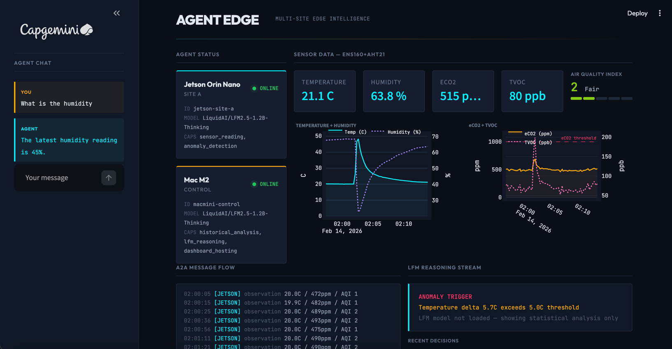

## Command Line Interface (CLI) To operate AgentEdge on the Jetson in a simple, reliable way, I implemented a dedicated command line interface (CLI). CLIs are likely to become the preferred interface for agent driven systems because they are fast, scriptable, automation friendly, and easy to integrate with tools, logs, and remote workflows.

I built a simple CLI that acts purely as a communication interface. It provides an interactive chat style loop to talk to the agent and a direct way to request and display sensor readings in real time. This approach keeps the interface minimal while making it easy to test conversations, validate tool use, and observe hardware signals without needing a full UI or external services.

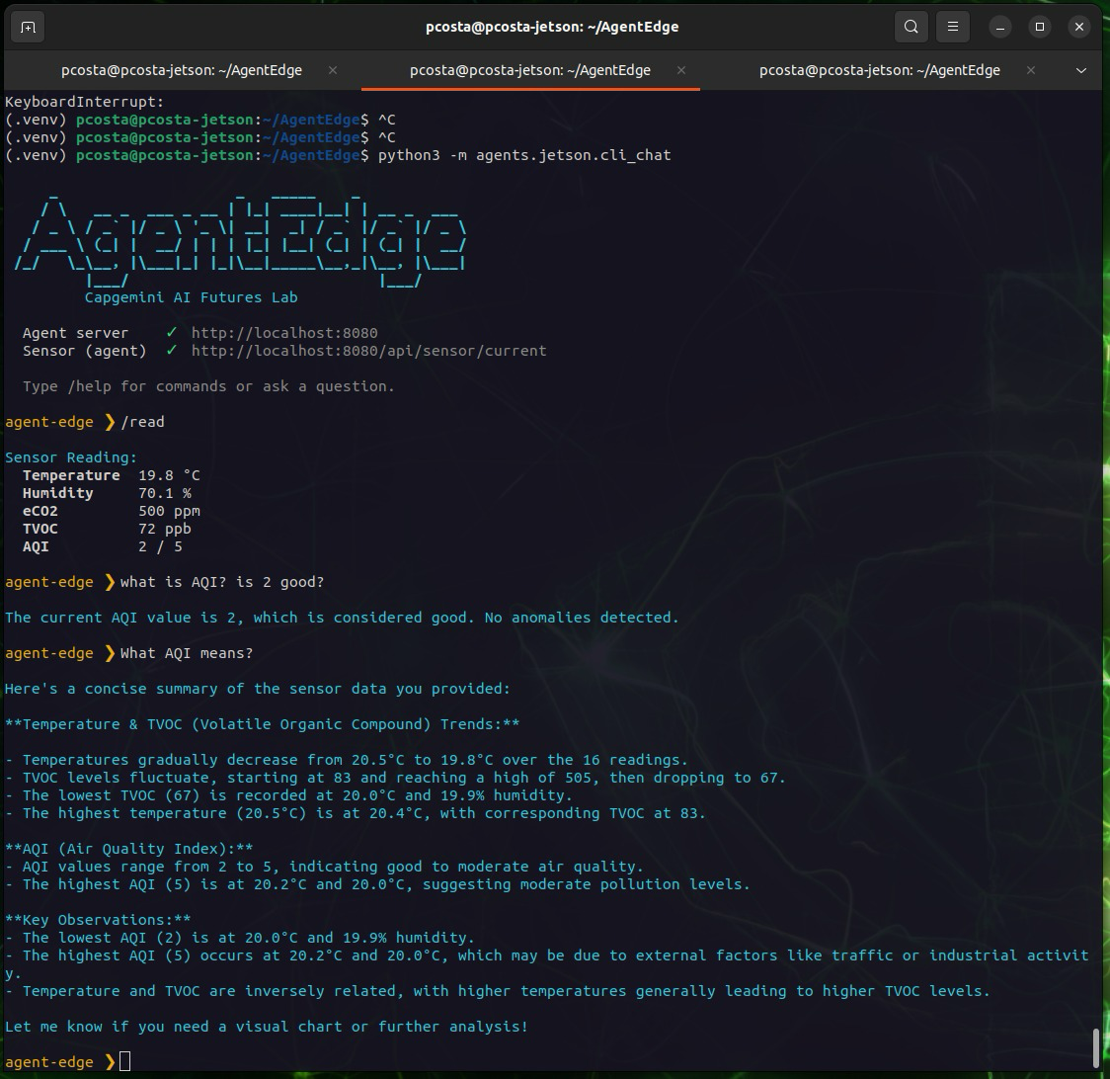

# 8. Anomaly Detection & Thresholds

The Jetson agent evaluates every sensor reading against four independent thresholds. If any single threshold is exceeded, the full anomaly analysis pipeline is triggered.

|  |  |  |  |
| --- | --- | --- | --- |
| Parameter | Threshold | Condition | Meaning |
| Temperature | > 5°C delta | vs. previous reading | Rapid temperature change |
| eCO2 | > 1000 ppm | absolute value | Poor indoor air quality |
| TVOC | > 500 ppb | absolute value | Elevated volatile organic compounds |
| AQI | ≥ 4 | absolute value | Unhealthy air quality (ENS160 scale) |

When triggered, the anomaly pipeline:

* Jetson runs local LFM analysis with current + previous sensor readings
* Jetson sends analysis_request to Mac with anomaly context and LFM reasoning
* Mac queries 24-hour historical statistics for all sensor fields
* Mac runs LFM analysis with historical context
* Mac returns analysis_response with confidence score
* Both agents log the collaborative decision
* All reasoning is streamed to the dashboard in real time

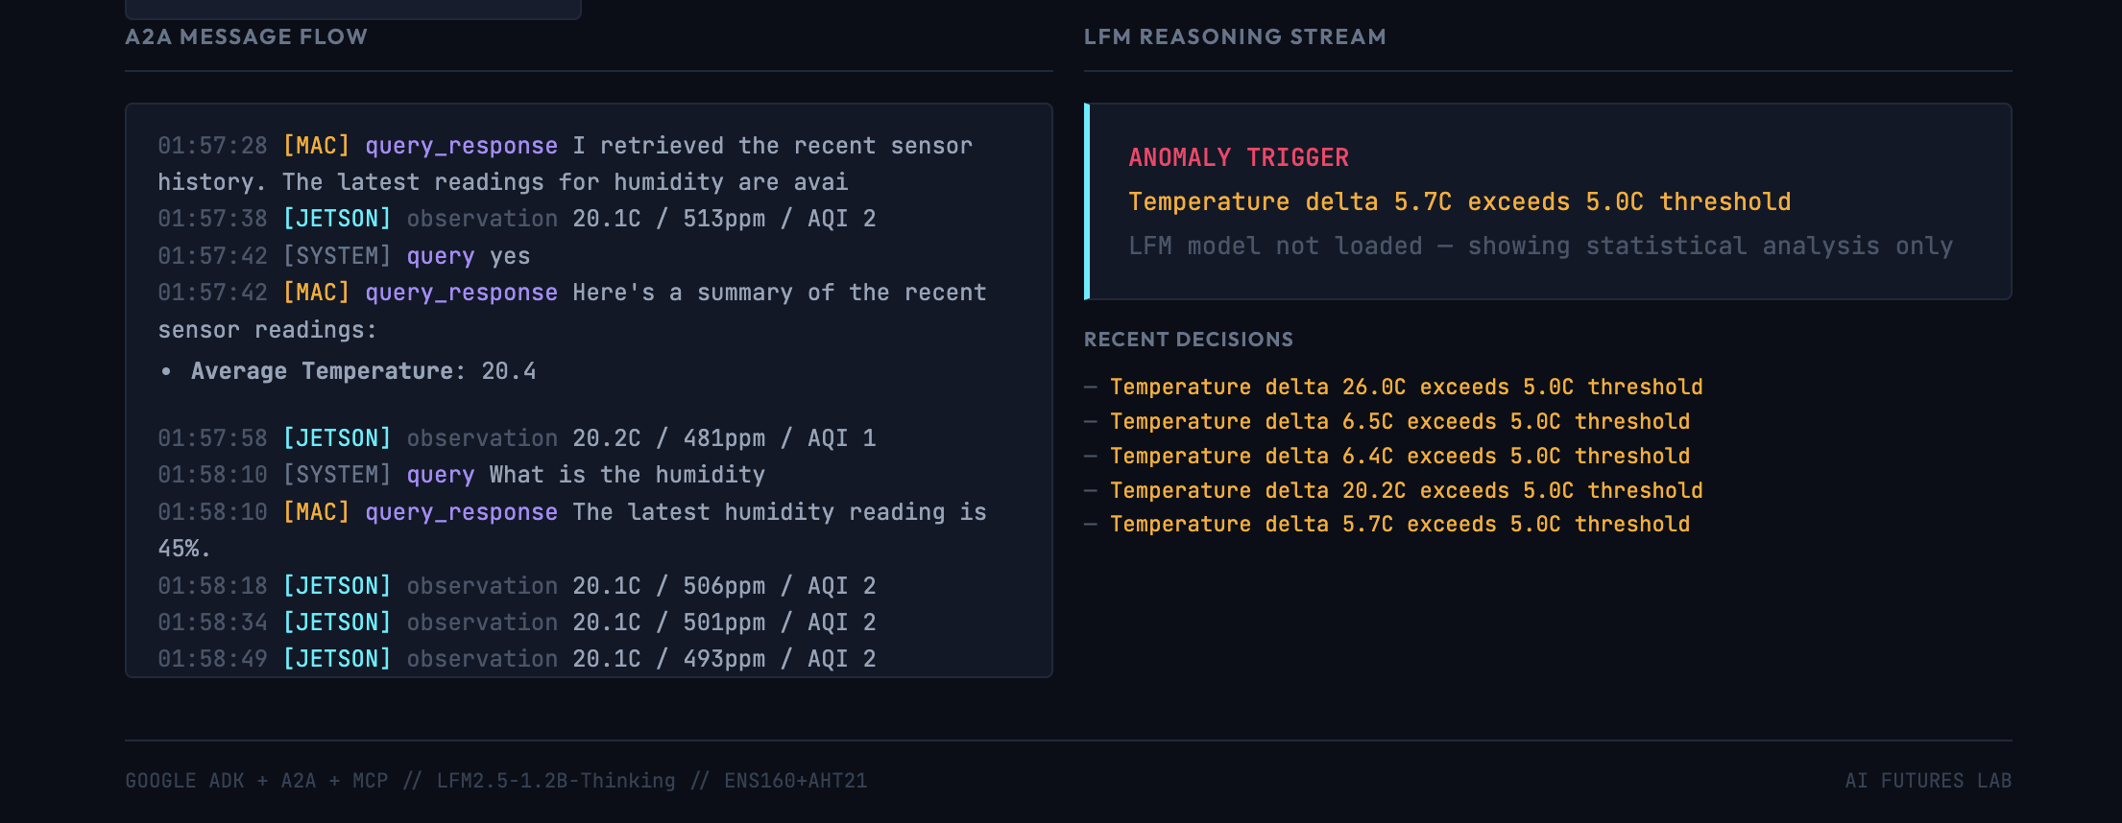

# 9. Deployment

## Demo Github Repo <https://github.com/codecube/AgentEdge>

## Project Structure

agent-edge/  
├── arduino/sensor_reader/sensor_reader.ino  
├── mcp_servers/arduino/server.py  
├── shared/  
│ ├── a2a_protocol.py  
│ ├── agent_card.py  
│ ├── lfm_client.py  
│ └── storage.py  
├── agents/  
│ ├── jetson/ (agent.py, config.py, mcp_client.py)  
│ └── macmini/ (agent.py, config.py)  
├── dashboard/  
│ ├── app.py  
│ └── components/ (sensor_viz, a2a_conversation, lfm_reasoning, agent_status)  
├── scripts/ (setup_jetson.sh, setup_macmini.sh, run_demo.sh)  
└── tests/

## Quick Start

Jetson Orin Nano (Site A):

bash scripts/setup_jetson.sh  
export MACMINI_AGENT_URL=http://<macmini-ip>:8081  
export SERIAL_PORT=/dev/ttyACM0  
python -m agents.jetson.agent

Mac (Control Center):

bash scripts/setup_macmini.sh  
export JETSON_AGENT_URL=http://<jetson-ip>:8080  
python -m agents.macmini.agent  
streamlit run dashboard/app.py

## Technology Stack

|  |  |
| --- | --- |
| Component | Technology |
| Language | Python 3.10+ |
| Agentic Framework | Google ADK |
| Agent Communication | A2A Protocol |
| Tool Integration | MCP (Model Context Protocol) |
| LLM | Liquid AI LFM2.5-1.2B (Ollama + LitLLM) |
| Dashboard | Streamlit + Plotly |
| Storage | JSON Lines (append-only, no database) |

# 10. Security Considerations for Agentic AI at the Edge

Autonomous AI agents operating at the edge introduce a new category of security challenges that traditional application security models are not designed to handle. These systems do not simply respond to requests; they perceive, reason, and act, often chaining tools and capabilities in ways that are difficult to predict or constrain. As edge agentic AI moves from prototype to production, security must be treated as a first-class architectural concern, not an afterthought.

## The OpenClaw wake-up call

OpenClaw, one of the fastest-growing projects in AI history, crossing 180,000 GitHub stars and attracting 2 million visitors in a single week. What followed was a rapid and public exposure of the security risks inherent in giving LLMs autonomous access to tools, APIs, and computer systems.

Security researchers discovered nearly 40,000 publicly accessible OpenClaw instances running without authentication. Of observed deployments, 63 percent were found to be vulnerable, with over 12,000 instances exploitable via remote code execution. Exposed data included API keys for cloud services, messaging tokens, and complete conversation histories. A security audit identified 512 vulnerabilities, eight of which were classified as critical. Third-party plugins, which OpenClaw calls "skills," were found to contain functional malware. The agent's autonomous decision-making meant that a single misconfigured permission could cascade into full system compromise.

OpenClaw demonstrated, at scale, that the agentic AI paradigm fundamentally changes the attack surface. The agent is not just a chatbot; it is an autonomous actor with tool access, and every tool it can invoke is a potential vector.

## Risks specific to edge agentic systems

Agent Edge, as an edge-native agentic system, faces a distinct set of security considerations:

**Agent-to-agent trust.** The A2A protocol enables agents to discover each other via agent cards and exchange messages using JSON-RPC. In a production deployment, agent identity must be verified. An attacker who can inject a rogue agent card into the discovery path could intercept or manipulate inter-agent communication. In the current demo, agent cards are served over HTTP without authentication, which is acceptable for a closed lab environment but would require mutual TLS or signed agent cards in production.

**Tool execution boundaries.** Both agents have access to tool functions: the Jetson agent reads sensors and detects anomalies; the Mac agent computes statistics and retrieves history. The MCP protocol gives the Jetson agent direct access to hardware via the Arduino serial interface. In a production scenario, tool invocations should be sandboxed, rate-limited, and auditable to prevent an LLM hallucination or prompt injection from triggering unintended physical actions.

**Prompt injection at the edge.** Edge agents that accept natural language input, whether from dashboards, APIs, or other agents, are susceptible to prompt injection. A crafted sensor reading or a manipulated A2A message could attempt to alter agent behavior. Defense in depth requires input validation at every boundary: sensor data schemas, A2A message validation, and strict tool function signatures.

**Data sovereignty and local inference.** One of Agent Edge's architectural decisions is that all LLM inference runs locally on-device using Ollama. No data leaves the edge. This eliminates an entire class of cloud-related risks (API key exposure, data exfiltration via model providers, third-party data retention). However, it shifts the security perimeter to the device itself: physical access to the Jetson or Mac means access to the model, the data, and the agent's tools.

**Serial port exclusivity and hardware trust.** The Arduino sensor interface uses exclusive serial port access through the MCP server. This is a deliberate design choice: only the sensor loop owns the hardware connection, and all other components access cached readings. This prevents race conditions and unauthorized hardware access, but the serial protocol itself is unencrypted and unauthenticated, which is typical for I2C sensor setups but worth noting for high-security environments.

## Design principles applied in Agent Edge

While Agent Edge is a demo, several security-aware design decisions were made:

**No cloud dependency.** All inference and data storage is local. Sensor data, conversation history, and agent state never leave the network.

**Exclusive hardware access.** The serial port is owned by a single process. Other components consume cached data, not raw hardware.

**Structured tool interfaces.** Agent tools use typed function signatures with explicit parameters, reducing the surface for injection compared to free-form tool descriptions.

**Append-only storage. JSON** Lines files are append-only, providing a natural audit trail for all sensor readings, anomaly events, and agent interactions.

**Protocol-level separation.** A2A handles agent-to-agent communication, MCP handles agent-to-system integration, and REST handles dashboard data. Each protocol has its own validation boundary.

## Looking ahead

The OpenClaw explosion made it clear that the industry needs security frameworks designed specifically for agentic AI. Traditional application security assumes a human is in the loop; agentic systems break that assumption. For edge deployments, where agents interact with physical hardware and operate in environments that may lack continuous human oversight, the stakes are even higher. Standards for agent identity, tool permission models, and inter-agent trust are still emerging, and this is an area where the industry must move quickly.

# 11. Future Directions

Agent Edge is a working prototype, but it also outlines a trajectory for where edge agentic AI is heading. Several natural extensions emerge from the current architecture.

### Multi-site scaling

The current system demonstrates two agents across two sites. The A2A protocol and agent card discovery model are designed to scale horizontally. A natural next step is deploying additional site agents, each with different sensor configurations, and having the control agent coordinate across a fleet. The ADK's RemoteA2aAgent abstraction already supports this: adding a new site is a matter of deploying another agent server and registering its agent card.

### Richer sensor fusion

The ENS160+AHT21 module provides environmental data, but edge AI becomes more compelling when agents fuse multiple sensor modalities: cameras for visual inspection, microphones for acoustic anomaly detection, accelerometers for vibration analysis. Each sensor type could be exposed through its own MCP server, and the agent would learn to cross-reference data across modalities, for example, correlating a temperature spike with a visual anomaly detected by a camera feed.

### Adaptive anomaly thresholds

The current anomaly detection uses static thresholds defined in configuration. A production system could leverage the local LLM to learn baseline patterns over time and dynamically adjust thresholds based on time of day, seasonal patterns, or operational context. The agent already has access to historical data through its tools; the next step is using that history to inform its own detection parameters.

### Agent negotiation and consensus

The current collaboration model is hierarchical: the Mac agent delegates to the Jetson agent when needed. More sophisticated multi-agent patterns include negotiation (agents proposing and counter-proposing actions), voting (multiple site agents reaching consensus on an environmental assessment), and escalation (agents recognizing when a situation exceeds their capability and requesting human intervention through structured channels).

### Streaming and real-time inference

The A2A protocol supports message streaming via Server-Sent Events, and the ADK framework can emit token-by-token updates. Enabling streaming would allow the dashboard to show agent reasoning in real time as it unfolds, rather than waiting for complete responses. Combined with WebSocket-based sensor streaming that is already in place, this would create a fully real-time experience from sensor to reasoning to visualization.

### On-device model evolution

Liquid AI's LFM architecture is optimized for edge deployment, but also on-device (smartphones) and the model landscape is evolving rapidly. As new SLMs emerge with better tool-use capabilities, longer context windows, and lower latency, the system can swap models without architectural changes, since LiteLLM abstracts the model layer. The interesting frontier is models that can be fine-tuned on-device using local operational data, creating agents that become specialized for their specific deployment environment over time.

### Production hardening

Moving from demo to production would require the security measures outlined in Chapter 10, along with: persistent agent sessions (currently stateless per request), robust error recovery and watchdog processes, over-the-air model and agent updates, monitoring and alerting infrastructure, and integration with enterprise identity and access management systems.

The core thesis of Agent Edge, that autonomous AI agents can perceive, reason, and collaborate at the edge without cloud dependency, is validated by this prototype. The path from here to production is primarily one of hardening, scaling, and trust, not fundamental architectural change.

# 12. Demo Scenario

The following scenario demonstrates the full Agent Edge system in action:

### Act 1: System Online

Both agents start and discover each other. The dashboard shows green status indicators. Sensor data begins flowing: temperature around 24°C, humidity 65%, eCO2 around 450ppm, AQI 1 (Good). The audience sees real data on real hardware.

### Act 2: Normal Monitoring

Every 5 seconds, the Jetson reads the sensor via MCP and sends an A2A observation to the Mac. The dashboard charts fill with data. The A2A message feed scrolls. Everything is within normal thresholds.

### Act 3: Anomaly Triggers

CO2 levels begin rising (simulated by breathing near the sensor or using a CO2 source). When eCO2 crosses 1000ppm, the Jetson’s anomaly detector fires. The dashboard turns amber.

### Act 4: Collaborative Intelligence

The Jetson runs LFM analysis locally: “CO2 spike while temperature is stable suggests poor ventilation rather than a heat source.” It sends an analysis request to the Mac. The Mac queries its 24-hour history, computes statistics, and runs its own LFM analysis: “eCO2 is 2.1 standard deviations above the historical mean. Recommend checking ventilation.”

The audience watches both LFM reasoning streams appear token-by-token on the dashboard. Two agents, on two different hardware platforms, collaborating to reach a decision, all at the edge, no cloud involved.

### Act 5: Resolution

The collaborative decision is logged by both agents. The dashboard shows the decision history. As CO2 levels return to normal, the system resumes routine monitoring.

**Key talking points for the audience:**

* Pure edge: zero cloud dependency, zero data leaving the room
* Open protocols: A2A and MCP are interoperability standards, not proprietary
* Visible reasoning: the audience can watch AI think, not just see outputs
* Real hardware: Jetson + Arduino + real sensors, not a simulation
* Practical: same architecture scales to industrial monitoring, smart buildings, fleet management

# 13. References & Further Reading

## Demo Github Repo <https://github.com/codecube/AgentEdge>

## Agentic AI / GenAI Augmentation

Claude Code and Anthropic Claude Opus 4.6

## Articles by Pedro Falcao Costa

**Agents Are the New APIs:** https://www.linkedin.com/pulse/agents-new-apis-pedro-falc%C3%A3o-costa-1ydpf/

**The A2A Protocol from Google Is Here and Changes Everything:** https://www.linkedin.com/pulse/a2a-protocol-google-here-changes-everything-pedro-falc%C3%A3o-costa-fggff/

**AI, Innovation & Edge Computing:** https://www.linkedin.com/posts/pedrofalcaocosta_ai-innovation-edgecomputing-activity-7250913453186441216-vAiO

## Protocols & Standards

* Model Context Protocol (MCP) , Anthropic, https://modelcontextprotocol.io
* Agent-to-Agent Protocol (A2A) , Google, https://google.github.io/A2A/

## Liquid AI & Capgemini

**Liquid AI:** https://www.liquid.ai/

**Liquid Foundation Models:** https://www.liquid.ai/models

**LFM2.5 Announcement:** https://www.liquid.ai/blog/introducing-lfm2-5-the-next-generation-of-on-device-ai

**Capgemini and Liquid AI Partnership:** https://www.capgemini.com/capgemini-and-liquid-ai/

**Capgemini AI Futures (Generative AI Lab):** https://www.capgemini.com/about-us/who-we-are/innovation-ecosystem/aifutures/

**What Are Liquid Neural Networks? (Capgemini):** https://www.capgemini.com/insights/expert-perspectives/what-are-liquid-neural-networks-and-why-should-you-care/

**LFM2.5-1.2B-Instruct on Hugging Face:** https://huggingface.co/LiquidAI/LFM2.5-1.2B-Instruct

## Hardware & Sensors

* ENS160 Digital Multi-Gas Sensor , ScioSense
* AHT21 Temperature & Humidity Sensor , Aosong
* Jetson Orin Nano, NVIDIA

# 14. Demo Development, Experimentation and Results

This demo was built using Claude Code with Claude Opus 4.6. The core ideas, vision, architectural design, and technology choices are my own. Total effort was about 6 hours, spread across 2 days. Agentic AI fundamentally changed the pace of development and made it possible to go from concept to working prototype in a single short iteration cycle.

### Unexpected results and failures (what I learned)

During implementation, I specified the architectural components and the protocol to use, but Claude implemented its own interpretation of the A2A protocol instead of the standard. Because I was operating under tight time constraints and in “vibecode” mode, I only caught this close to the finish line. For me, aligning with the standard was non negotiable, so this triggered a major refactor late in the process. Claude handled the refactor well, but it was not a one shot fix. It took a few iterations to converge. Lesson learned: protocol compliance needs an explicit validation checkpoint early, not at the end.

### Model behavior observations (reasoning vs instruct)

Reasoning models like LFM2.5 Thinking tended to introduce noticeable latency and consumed a high number of thinking tokens for this type of iterative build. In practice, I switched to LFM2.5 Instruct to keep the development loop fast and responsive. That said, I still see a clear role for reasoning models at the edge, especially for decision making, planning, and handling ambiguous situations where deliberate reasoning is worth the cost.

### Hardware integration challenges

I initially planned to connect the sensor directly through the NVIDIA Jetson Orin Nano 40 pin GPIO header. In reality, the developer kit is not trivial to customize at this level under time pressure, particularly when you want a smooth, predictable hardware software debugging loop. To keep momentum, I switched to an Arduino and integrated the sensor via serial communication. This simplified wiring, reduced friction, and made troubleshooting faster.

### Why this demo matters now

This is a demo I had been planning for more than a year, well before MCP, A2A, and the recent wave of local SLMs with tool use. These new protocols, combined with practical on device models, were the missing enablers that finally made the concept feasible and buildable as a compact, end to end edge prototype.

Author

Pedro Costa

Head of GenAI   
Capgemini Engineering  
Middle East

pedro.costa@capgemini.com

Publication year

February 2026

About Capgemini

Capgemini is a global business and technology transformation   
partner, helping organizations to accelerate their dual transition to   
a digital and sustainable world, while creating tangible impact for   
enterprises and society. It is a responsible and diverse group   
of 340,000 team members in more than 50 countries. With its strong   
over 55-year heritage, Capgemini is trusted by its clients to unlock the   
value of technology to address the entire breadth of their business needs.   
It delivers end-to-end services and solutions leveraging strengths from   
strategy and design to engineering, all fueled by its market leading   
capabilities in AI, generative AI, cloud and data, combined with its deep   
industry expertise and partner ecosystem. The Group reported 2024   
global revenues of €22.1 billion.

Make it real. | [www.capgemini.com](https://www.capgemini.com/)



This presentation contains information that may be privileged or   
confidential and is the property of the Capgemini Group.

Copyright © 2025 Capgemini. All rights reserved